Software Testing (CS 4036)
Date: 06th April, 2026
Course Instructor(s):
Mr. M. Waqas, Mr. Usman Aamer

Sessional-II Exam
Total Time (Hrs): | 1
Total Marks: | 45
Total Questions: | 3

___________ __________ _____________________
Roll No Section Student Signature

Answer all questions. Answer questions in the same order as they appear on question paper. Answer all questions on answer sheets.

Question1: [10+5]
Consider a program that determines the previous date. The possible outputs are ‘previous date’ or ‘invalid input’. Its inputs are a triple of day, month and year with its values in the range:
1 <= month <= 12
1 <= day <= 31
1850 <= year <= 2050
Task:
- Generate test cases for
Boundary Value Analysis – 5 States – 4(n)+1 = 13
and Robustness testing - 7 States – 6(n) + 1 = 19
- Write number of test cases required for Worst Case Testing 5^n = 125
Robust Worst Case Testing 7^ n = 343

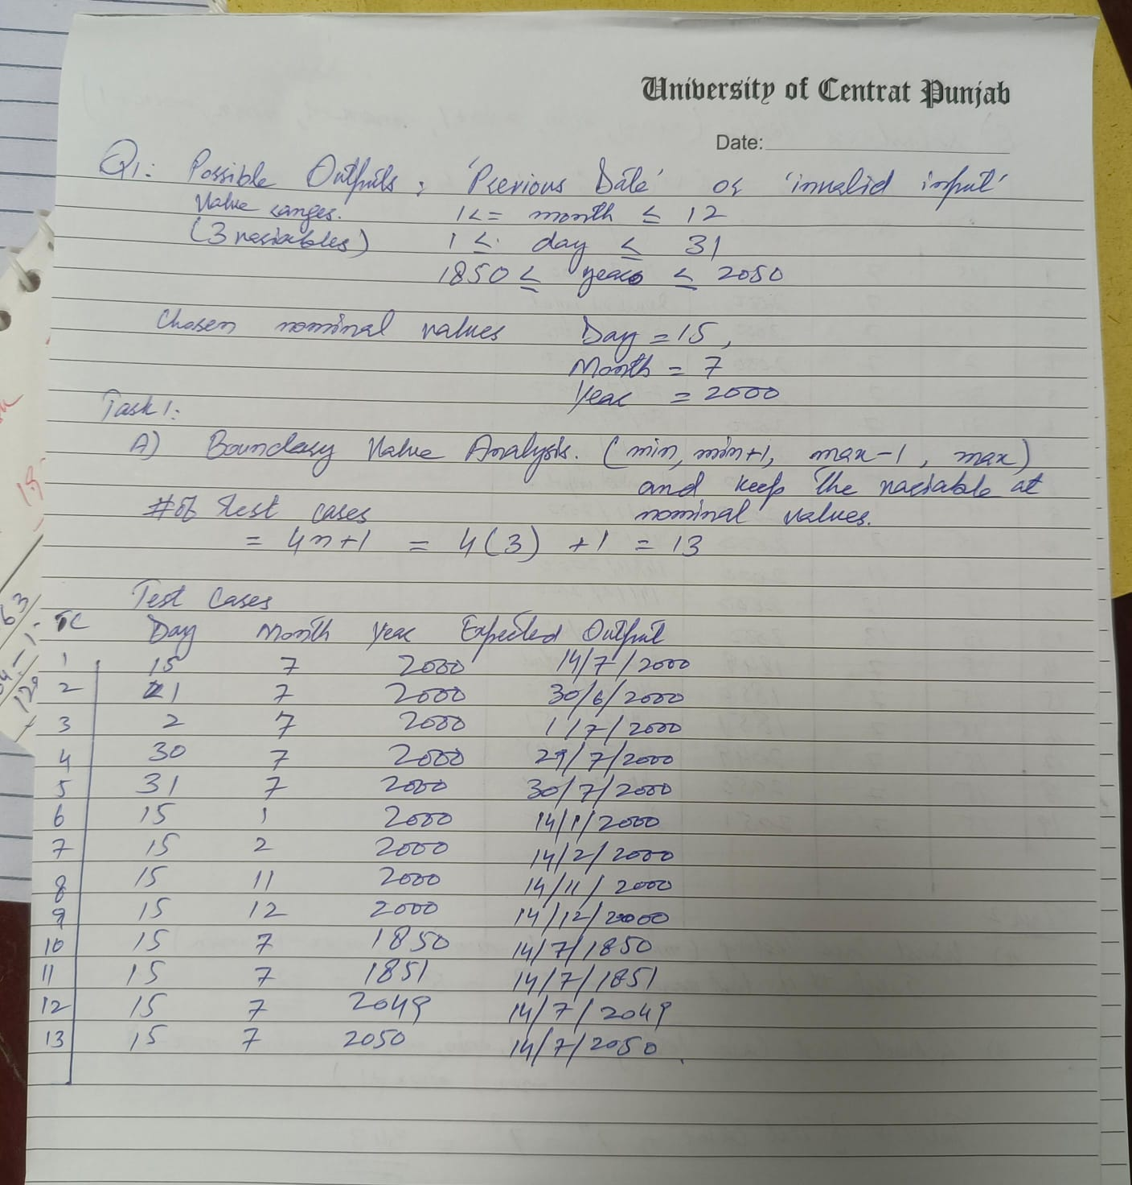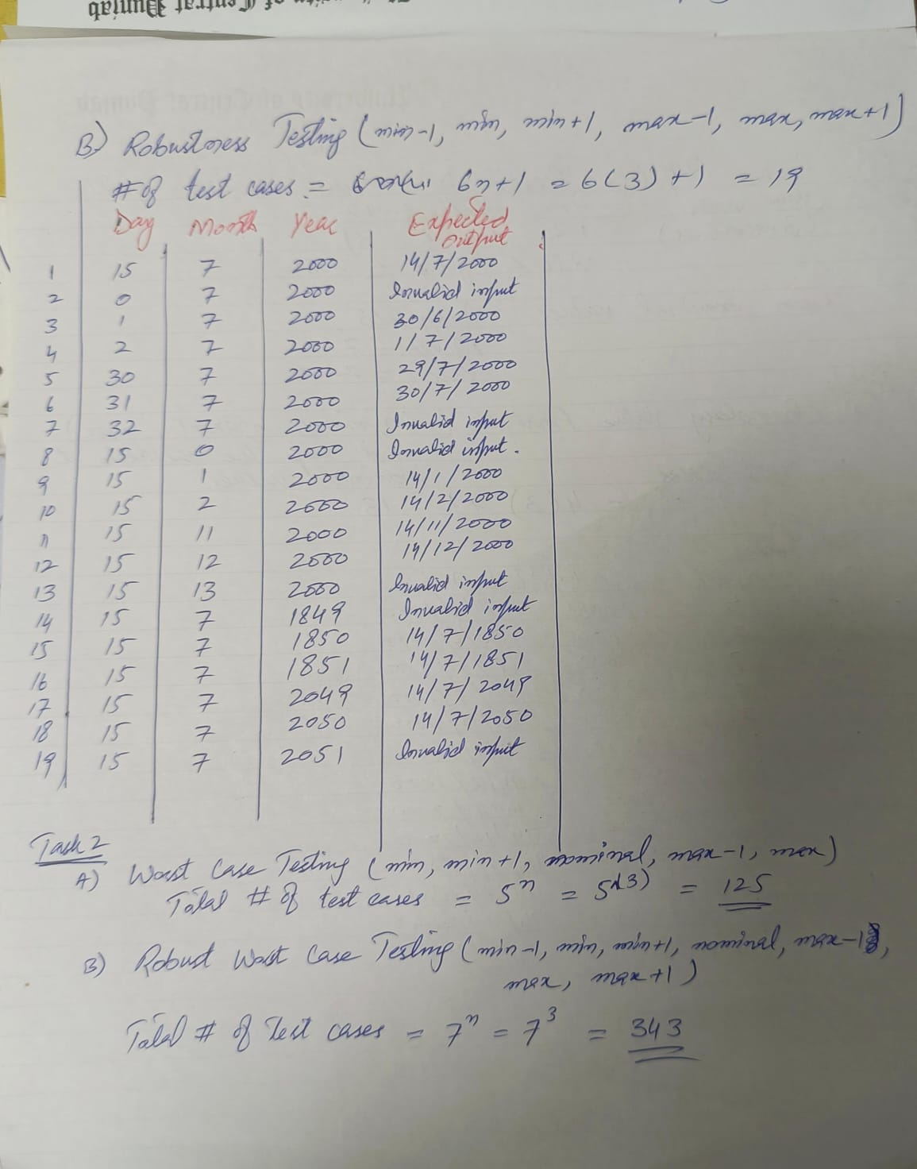
Question 2: [10+5]
A system determines whether a user is eligible for a loan approval based on the following conditions:
Conditions  C1: Income ≥ 50,000  C2: Credit score ≥ 700  C3: Existing loan = Yes | Actions  A1: Loan Approved  A2: Loan Approved with Conditions  A3: Loan Rejected

Business Rules
- If income is less than 50,000 → Loan Rejected
- If income ≥ 50,000 & credit score ≥ 700 and no existing loan → Loan Approved
- If income ≥ 50,000 & credit score ≥ 700 and existing loan → Loan Approved with Conditions
- If income ≥ 50,000 but credit score < 700 → Loan Rejected
Task:
- Create Decision Table
- Create a reduction decision table showing all steps

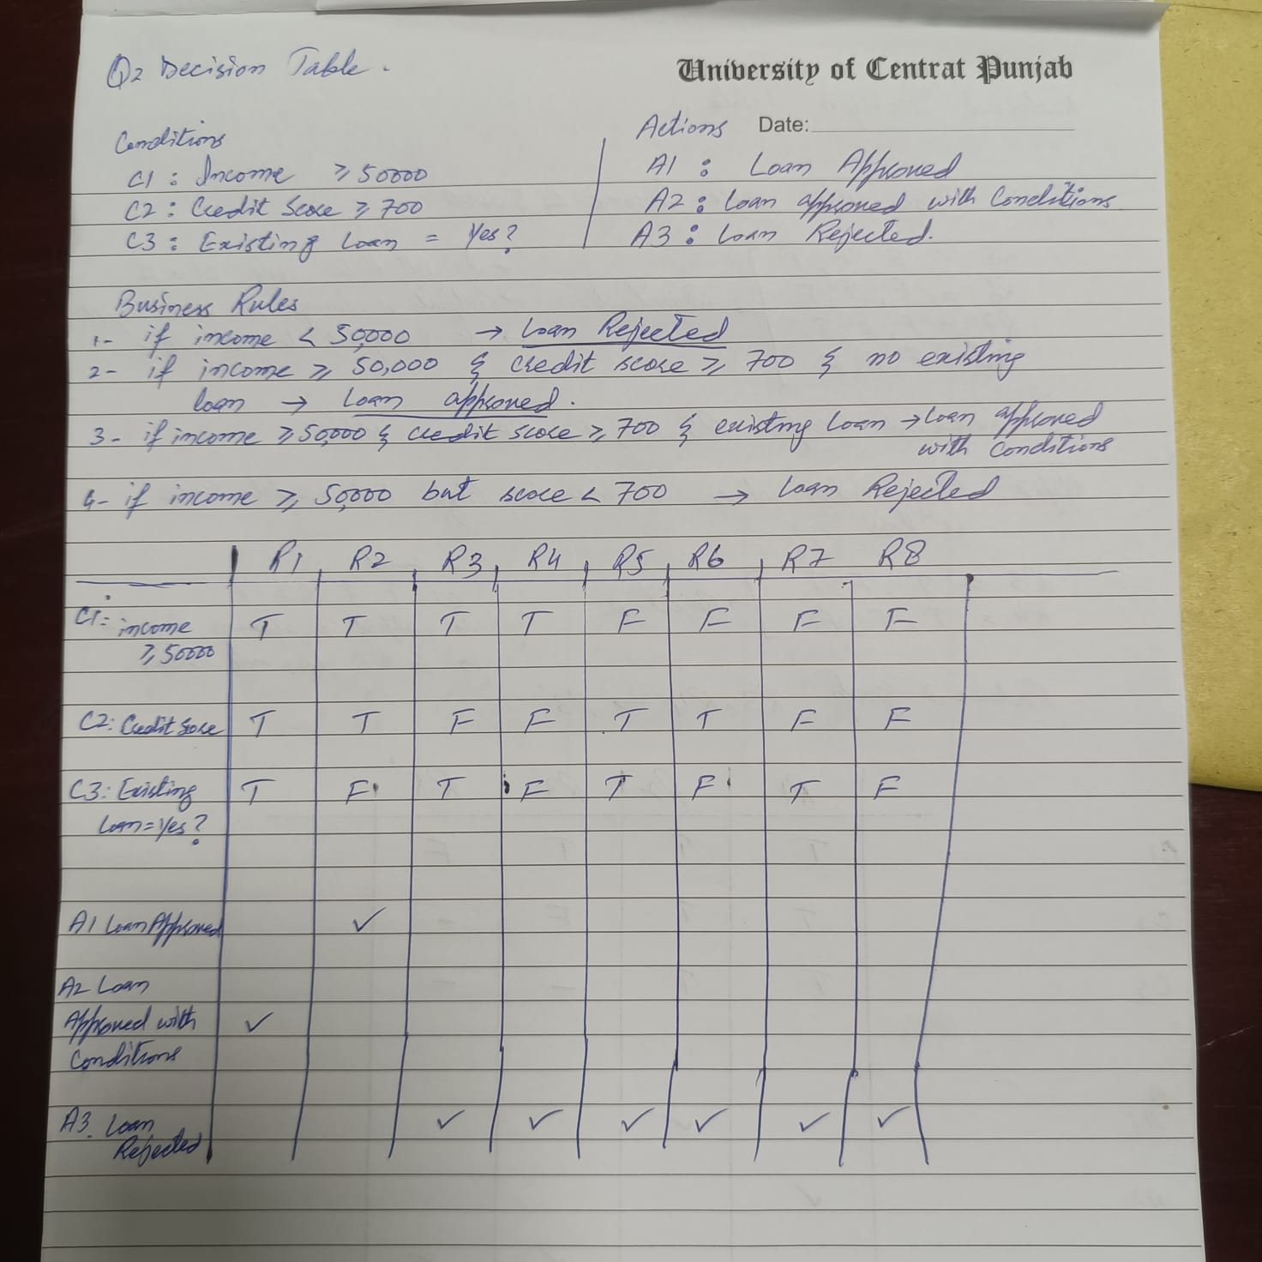

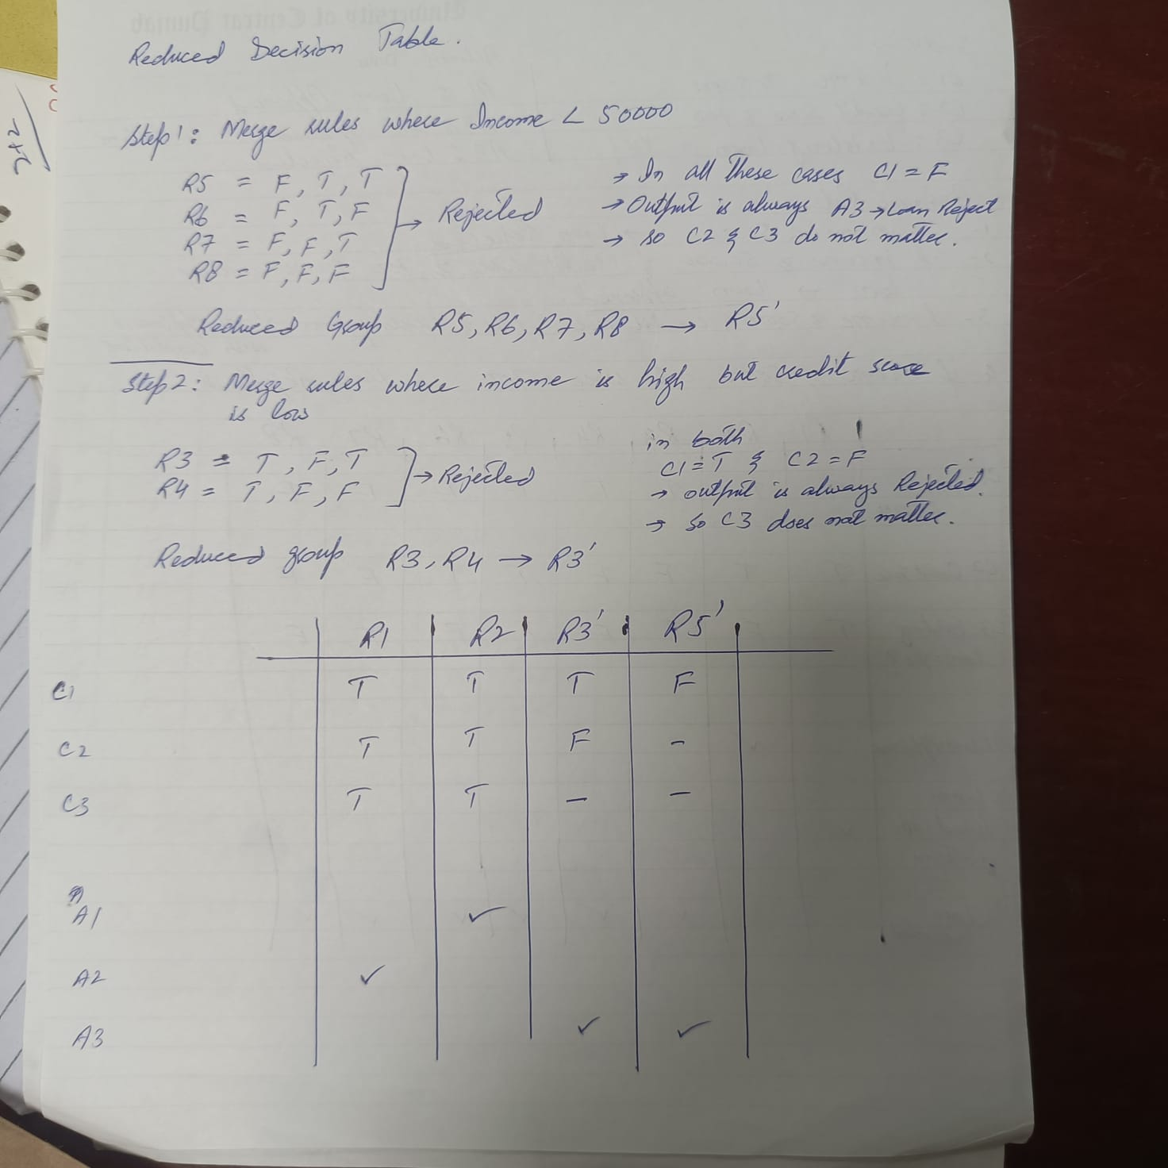
Question 3: [10+5]
You are the Lead QA Engineer for a new high-end Coffee Brewing Station. The system allows users to customize their brewing experience through a digital interface. To ensure the software correctly handles different configurations, you need to perform integration testing on the following parameters:
- Brew Method (P1​): Espresso, Drip, French Press
- Water Temperature (P2​): Warm, Hot, Boiling
- Grind Size (P3​): Fine, Medium, Coarse
- Milk Frother (P4​): Off, Low, High
Task:
- Identify which of the three provided Orthogonal Arrays (Table A, Table B, or Table C) is valid for an L9​(3^4) design.
- Using the valid array identified in Task 1, map the specific coffee station values to the array levels and present the final set of 9 test cases.
Table A:  Test Run P1​ P2​ P3​ P4​  1 0 0 0 0  2 0 1 1 1  3 0 2 2 2  4 1 0 1 1  5 1 1 2 2  6 1 2 0 0  7 2 0 2 2  8 2 1 0 0  9 2 2 1 1 | Table B:  Test Run P1​ P2​ P3​ P4​  1 0 0 0 0  2 0 1 1 1  3 0 2 2 2  4 1 0 1 2  5 1 1 2 0  6 1 2 0 1  7 2 0 2 1  8 2 1 0 2  9 2 2 1 0 | Table C:  Test Run P1​ P2​ P3​ P4​  1 0 0 0 0  2 1 1 1 1  3 2 2 2 2  4 0 1 2 0  5 1 2 0 1  6 2 0 1 2  7 0 2 1 0  8 1 0 2 1  9 2 1 0 2

